Professor Comments:
This section about e-commerce is supposed to be a discussion of the Tencent’s mobile applications and website. Here you should focus on identifying features which make Tencent’s website and applications unique, in comparison to their competitors.

The company we wrote is Tencent company!

Future Opportunities
Having gained significant success as China's largest gaming and social media company, Tencent is evaluating its future opportunities, which the company can invest in generating more profits. However, one of the key future opportunities for Tencent is advertising. Notably, the company controls the largest social network platforms in China: WeChat and QQ, with approximately one billion users. Nevertheless, the platforms are significantly under-monetized. Besides, it has been reported that WeChat users only see an average of three ads a day, which is very low compared to other social network platforms such as Facebook, where its users view more than 20 ads per day (BSIC, 2019). Therefore, Tencent is planning to increase its ad content in WeChat to monetize the significant WeChat traffic.
In addition, Tencent is also involved in music entertainment, owning China's most prominent music streaming company. However, in an article published by the Wall Street Journal, Tencent planned to invest more in the music entertainment sector by acquiring a minority stake in the Universal Music Group (BSIC, 2019). This is to help the company achieve its long-term goals of becoming the leading company in China in the international music business. Another future opportunity for Tencent is becoming the top player in the Industrial Internet of Things (IIoT). Notably, the Industrial Internet platform is projected to be worth $123B by the end of 2021, with China claiming one-third of the world’s total value estimably (BSIC, 2019). Therefore, with its vast online platform, Tencent can engage in data collection and analysis to help industrial businesses gain intelligence provided by sensors. Besides the IIoT, the company will benefit more because it will significantly diversify away from its current customer-oriented streams. As a result, this will help reduce the company's exposure to economic and political aspects hence stabilizing its future revenue streams.

Trends in the Internet Markets
Notably, having previously integrated minimum trends in its huge social network platform, Tencent is planning to increase its trends in the internet market. Besides, with its strong global reputation, and as a leading agency in the internet market, Tencent will introduce threeData Management Platform (DMP) functions. This will be included in Tencent Social Ads to enhance its efficiency of the digital market as well as creating a brand that will be relevant for many years to come. Studies have shown that Chinese online users spent at least three hours on the internet. On the other hand, Tencent products reach approximately 90% of internet users (Beyond Summits, 2021). In 2015, the company's financial report showed that the company's QQ and QQ zone platforms had 843M and 659M subscribers, respectively (Beyond Summits, 2021).
Therefore, it is evident that its success depends on its ability to maintain its online followers and foster a favorable long-term relationship. Hence, based on this aspect, Tencent Social Ad is in a position to identify its consumers' demands because of its ability to access online records for their users, which helps them establish their trends strategy. Therefore, the company is in a position to develop customized ads for a targeted group (Beyond Summits, 2021). For instance, Tencent may also partner with a car manufacturer to support them and create differences tags from each of the categories which will be used to create trends in its online platforms hence influencing its online viewers on the final purchase decision.

E-commerce Appearance
Being one of the technology heavyweight in China, Tencent is planning to make a venture into the online shopping business, aiming to benefit from its one billion online users in their WeChat app. Since last summer, Tencent has been testing its new app function, WeChat mini shop, where it allows companies and entrepreneurs to start an online shop store easily. In addition, sellers can include clips showcasing how their product works. On top of selling their goods and services, the online store owners are in a position to feature products on other E-commerce sites which are in partnership with Tencent, such as JD.com (Hinata, 2021). This enables the owners to have a broader market; hence they are in a position to collect the commission on a sale of their third party goods.
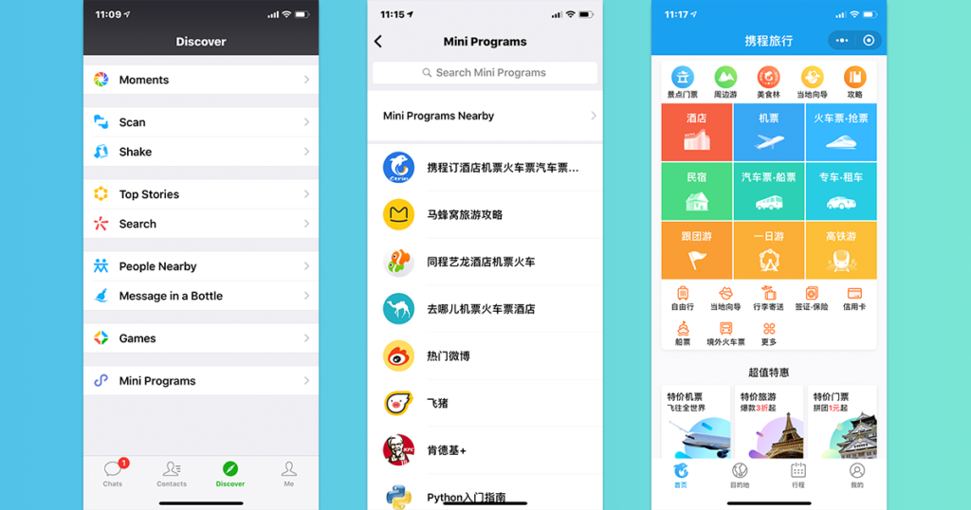
Notably, the E-commerce market in China is dominated mainly by the Alibaba Group, which holds approximately half of the market's share value. JD.com is the second dominant company, holding about 20% of the market share. Pinduoduo and another platform supported by Tencent come third with over 10% of the shared control (Hinata, 2021). Therefore, with the introduction of the online shopping business, Tencent hopes it can challenge Alibaba with the aid of Pinduoduo resources and the JD.com partnership. Besides, the company has previously successfully connected their WeChat users with services offered by their investees and partners. For instance, WeChat users are in a position to easily share products and stores on JD.com, a feature that is not applicable for links to Alibaba Products.

